Exam #2- CHEM 330- Fall 2025

Name……………………………………………………………………………………………….
A) Multiple Choice Section (30 min). 24 questions. Only one correct answer. 2.5 points each.

1) In the first step of ethanol metabolism in the liver, ethanol is oxidized to acetaldehyde through the action of alcohol dehydrogenase (ADH):

ethanol + NAD⁺ → acetaldehyde + NADH + H⁺ (ADH reaction)

Ethanol can be also oxidized to acetaldehyde through a minor pathway catalyzed by an enzyme called cytochrome P450 2E1 (CYP2E1). This enzyme catalyzes the following reaction:

ethanol + O₂ + NADPH + H⁺ → acetaldehyde + 2 H₂O + NADP⁺ (CYP2E1 reaction)

The K_{m} for ethanol oxidation by CYP2E1 is 10 mM; the K_{m} for ethanol oxidation by ADH is 1 mM. Assume that Vmax for both CYP2E1 and ADH is the same. After drinking two beer cans, the approximate blood ethanol concentration in a standard 70 kg male is 10 mM. Under these conditions:

ADH CYP2E1
A) not active not active
B) v_{o}=Vmax/2 not active
C) v_{o} =Vmax v_{o} =Vmax
D) v_{o} =Vmax/2 v_{o} =Vmax/2
E) v_{o} =Vmax v_{o} =Vmax/2

2) Michaelis and Menten assumed that the overall reaction for an enzyme-catalyzed reaction could be written as

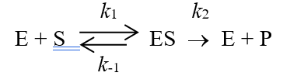
Using this reaction, the rate of breakdown of the enzyme-substrate complex can be described by the expression:

A) k₁ ([E_{t}] - [ES])
B) k₁ ([E_{t}] - [ES])[S]
C) k₂ [ES]
D) k₋₁ [ES] + k₂ [ES]
E) k₋₁ [ES]

3) The initial velocity assumption for Michaelis-Menton kinetic assumes that_________

A) the reaction is always running at Vmax.
B) the rate of E + P -> ES is negligible.
C) a large amount of product has formed.
D) k₋₂ is large.
E) none of the above.

4) The kinetic data in the table below were obtained using an enzyme known to follow Michaelis-Menten kinetics:
The Km for the substrate of this enzyme is approximately:

A) 325 micromol/min
B) 650 micromol/min
C) 2 mM
D) 4 mM
E) 500 mM

5) In the following diagram of the first step in the reaction catalyzed by the protease chymotrypsin, the process of general base catalysis is illustrated by the number ________, and the process of covalent catalysis is illustrated by the number _________.

- 1; 2
- 1; 3
- 2; 3
- 2; 1
- 3; 2

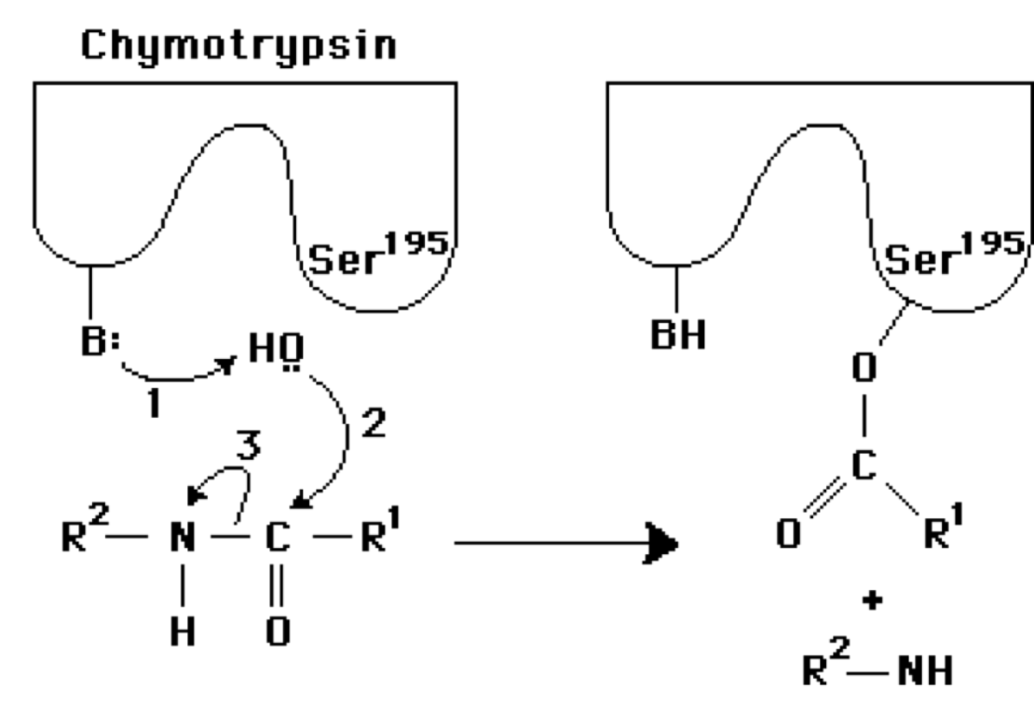

6) Which of the 'change in free energy' arrows in the diagram below represents 'binding energy'?

A) A
B) B
C) C
D) D
E) none of the arrows represent “binding energy”

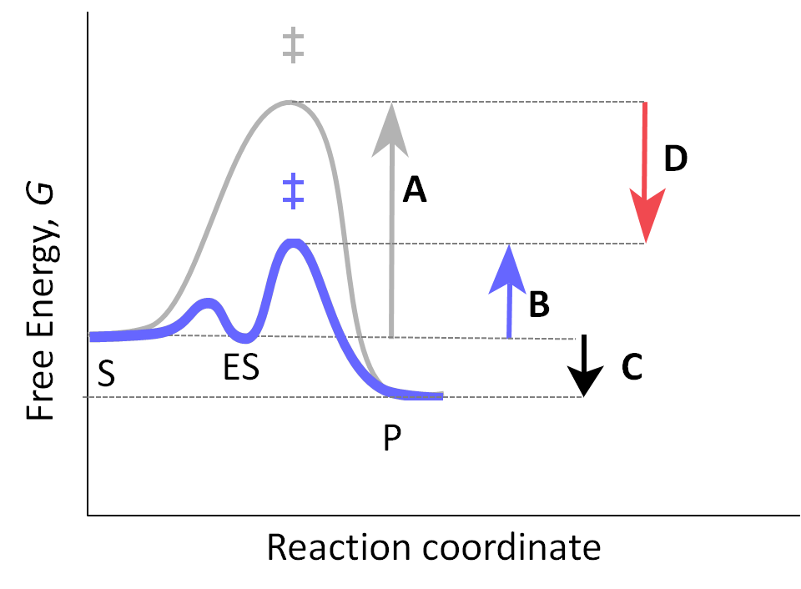
7) Based on the plot shown (rate = kcat), which of the following statements is NOT true?

A) The optimal pH of this enzyme would be around 7
B) The residue with a pKa of 4 is likely acting as a general base in catalysis at the optimal pH.
C) At the optimal pH, the residue with a pKa of 10 is in its conjugate base form.
D) The residue with a pKa of 4 could be a Asp or Glu residue
E) All of the above are true statements

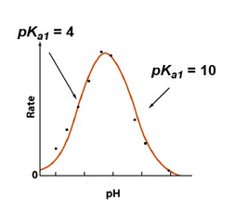
8) AMP is a positive allosteric regulator of the enzyme phosphofructokinase-1. It:

- Increases the number of T conformations
- Causes a shift to the right in the sigmoid V₀ vs [S] curve
- Stabilizes the T state, increasing K_{0.5}
- Decreases the cooperativity of the substrate
- Stabilizes the R state, decreasing K_{0.5}

9) Which of the following diagrams best describes the equilibria associated with a competitive inhibitor (I)?

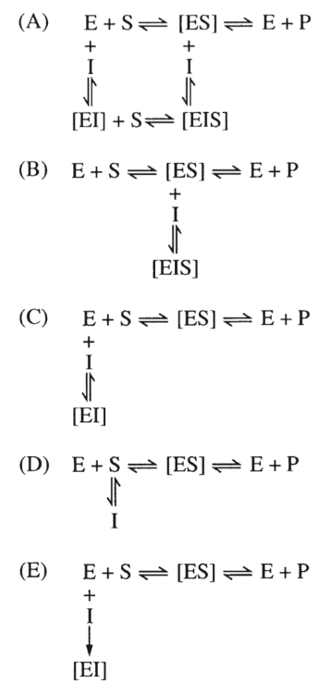

10) The reaction below is catalyzed by an enzyme belonging to which class of enzymes?

- Hydrolase
- Oxidoreductase
- Isomerase
- Ligase
- Transferase

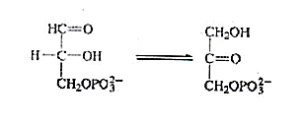

11) Which of the following side chains is least likely to function as a nucleophilic catalyst?

A) cysteine
B) serine
C) histidine
D) alanine
E) tyrosine

12) Which of the following structures is most likely to be an effective competitive inhibitor of the enzyme proline racemase, which catalyzes the reaction below:

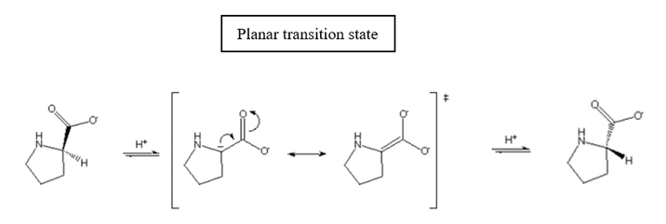

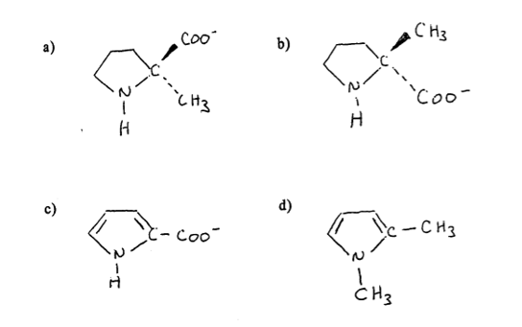

13) How many reducing ends are in a molecule of glycogen that contains 10,000 residues with a branch every 10 residues?

A) 10,000
B) 1,000
C) 100
D) 10
E) 1

14) Which of the following statements about starch and glycogen is false?

A) Amylose is unbranched; amylopectin and glycogen contain many (α1 → 6) branches.
B) Both are homopolymers of glucose.
C) Both serve primarily as structural elements in cell walls.
D) Both have (α1 → 4) glycosidic bonds.
E) Glycogen is more extensively branched than starch.

15) The enzyme citrate synthase catalyzes the biosynthesis of citrate using acetyl-coA and oxaloacetate as substrates. The biomolecules (adenylate nucleotides) ATP, ADP and AMP were found to be inhibitors of citrate synthase, as shown in the following plots:
Complete the following sentence using the options below:

ATP is a(n) --------------------inhibitor with respect to acetyl-coA.

- Allosteric
- Competitive
- Uncompetitive
- Mixed
- Pure noncompetitive

16) Which of the following represents L-fructose?

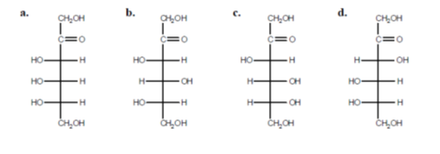

17) You are testing several enzyme variants that catalyze the same reaction. The kinetic parameters are shown below:
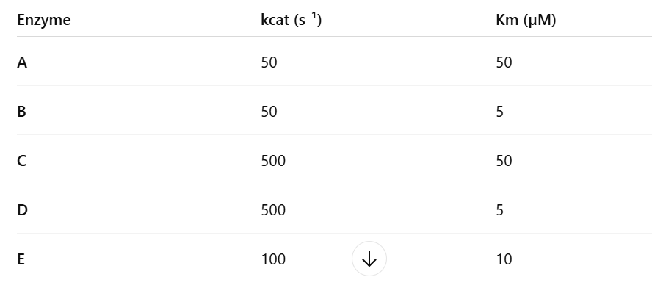
Which enzyme would be expected to catalyze the reaction most efficiently?
A) Enzyme A
B) Enzyme B
C) Enzyme C
D) Enzyme D
E) Enzyme E
18) In the following compound, carbon _______ (i) is the anomeric C, and carbons _______ (ii) are chiral.
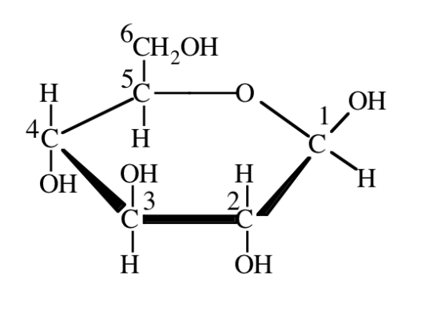
- i=6 and ii= 2,3,4,5
- i=2 and ii= 3,4,5,6
- i=1 and ii= 1,2,3,4,5
- i=5 and ii=6
- i=1 and ii=1,2,3,4,5,6

19) Which chemical group determines that this is a 'reducing' disaccharide?

A) A
B) B
C) C
D) D
E) E
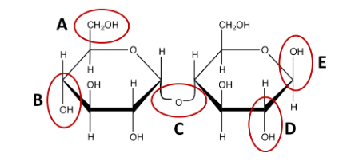
20) In the glucose molecules shown, which of the circled carbons will become the anomeric carbon in the cyclic structure?

A) A
B) B
C) C
D) D

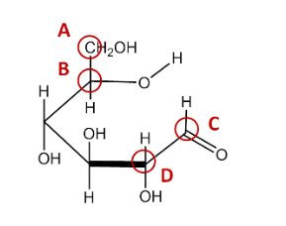
21) Which of the following sugars cannot exist in a cyclic form? Note: “CHO” represents an aldehyde group.

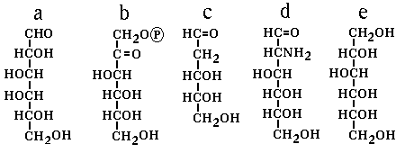
22) Which of the following best describes the following two structures?

- They are C2 epimers
- They are both aldose sugars
- They are anomers
- They can form hemiketal bonds
- Can be interconverted by an isomerase

23) Which of the following disaccharides is a non-reducing sugar?
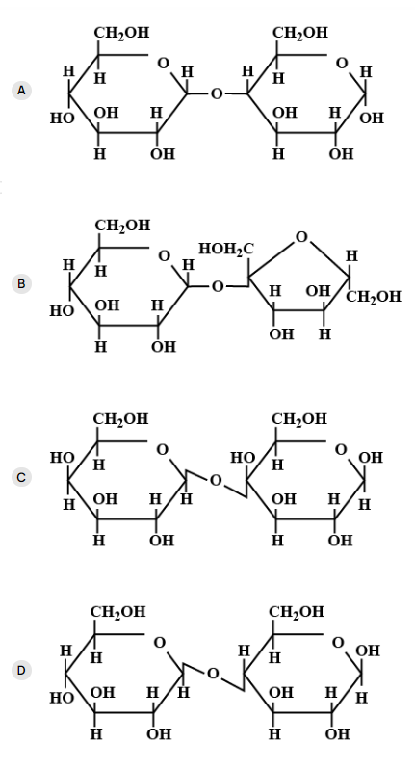
24) The only false statement (out of A, B, C, D and E) below concerning Y is_____________

- Y is a reducing sugar because it has one free anomeric carbon atom
- Y has a (β1→ 4) glycosidic linkage and has β-configuration on its free anomeric carbon
- On hydrolysis, one mole of Y will yield one mole each of glucose and galactose (a C4 epimer of glucose)
- Y is not a reducing sugar because all its anomeric carbon atoms are involved in glycosidic bonds
- Y does not contain a furanose ring in its structure

B) Short Answers Section (20 min). 4 questions. 10 points each
1) a) The enzyme enolase catalyzes the conversion of 2-phosphoglycerate (2PG) into phosphoenol pyruvate (PEP), an important step in the breakdown of sugars. The mechanism of the first step in the enolase reaction is shown below:

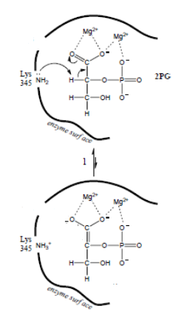
Consider the components involved in the enolase mechanism, including the active-site residue Lys345 and the Mg²⁺ cofactors, and complete the table below:

Component | Catalytic mechanism  (name) | Catalytic mechanism (describe)
Lys³⁴⁵

Mg²⁺

b) In 2004, the protease field was honored by a Nobel Prize in Chemistry presented to Avram Hershko, Aaron Ciechanover, and Irwin Rose for their pioneering work on the proteasome system, in which the proteasome is a novel threonine protease. Very recently, a new mechanism for proteolysis in the proteasome was proposed by a multinational group:

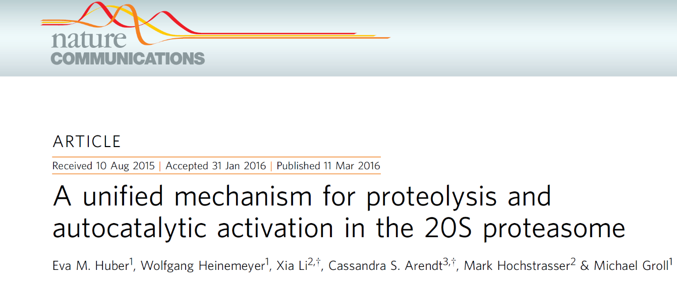

“On the basis of these results, we propose that the proteasome from all domains of life uses a catalytic triad consisting of Thr1, Lys33, and Asp17 for proteolysis”.

• Thr1 acts as the nucleophile.
• Lys33 acts as the base that activates Thr1.
• Asp17 stabilizes the protonated Lys33.

Complete the mechanism (shown below) for the first step of catalysis in the active site of the proteasome. Use curly arrows to show the movement of electron pairs.

Residues: T1 (Thr1), K33 (Lys33), D17 (Asp17). The peptide bond to be cleaved is on the left.
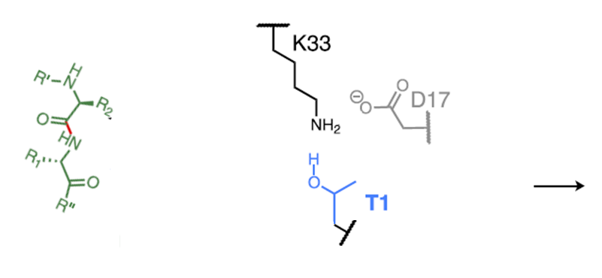
2) a) i) Below is the open-chain structure of D-idose, an aldohexose. a) On the backbone provided, draw the cyclic form. ii) What is the full name of the sugar you have drawn?

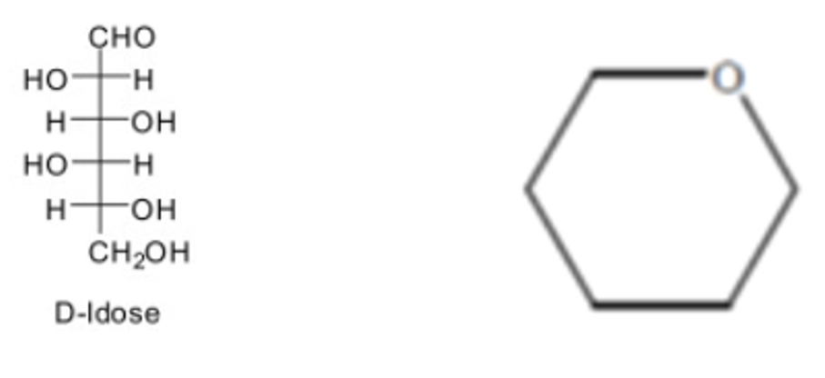

b) i) Name the disaccharide drawn below:
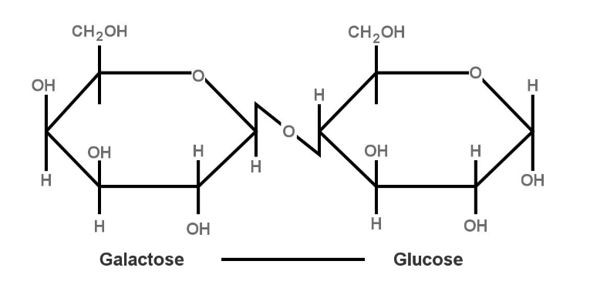

3) a) You measure the initial velocity (V₀) of an enzyme at six different substrate concentrations, then plot these data on a Lineweaver-Burk plot (below). Calculate the Michaelis-Menten parameters for this enzyme. Show your work.

- The Vmax of the enzyme is:______________________

- while the Km of the enzyme is __________________.

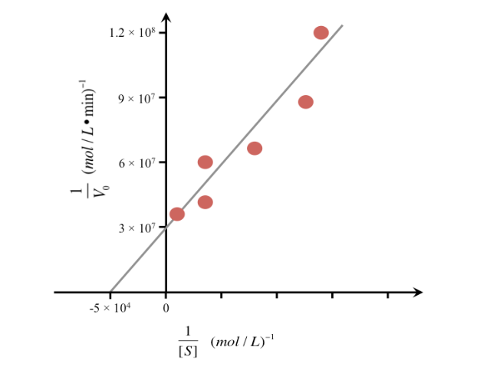
b) You are a biochemist studying unusual carbohydrates found in rare rainforest plants. You have isolated a polysaccharide that contains alternating β(1→4) and β(1→3) linkages between D-glucose residues.
On the framework provided:
- Complete each cyclic β-D-glucopyranose structure.
- Connect the first two glucose units with a β(1→4) O-glycosidic bond.
- Connect the last two units with a β(1→3) O-glycosidic bond.
- Clearly label each glycosidic linkage (β1→4 and β1→3) on your drawing.

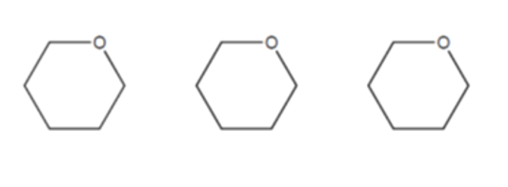

4) For each polysaccharide listed below (cellulose, amylose, amylopectin, and glycogen), indicate Yes or No for each characteristic in the table.

 | Cellulose | Amylose | Amylopectin | Glycogen
β 1→4 bonds

α 1→4 bonds

α 1→6 bonds

Helical

Storage polysaccharide

